Age & age are two different names in py.

NEED CAPITALS FOR True and False:

boolean  
age = True

Print (type(age))

Int

Age = 32

Print(type(age))

Str

Age = ‘hello’

Print (type(age))

Or

Str

Age = “hello”

Print (type(age))

list

Age = []

Print (type(age))

Tuple

Age = ()

Print (type(age))

Dict

Age = {}

Print (type(age))

Variable names have to start with a character

Key take away is that variables have types & you will have to convert from one variable to another to concatenate

Always explain what you are doing

Lab

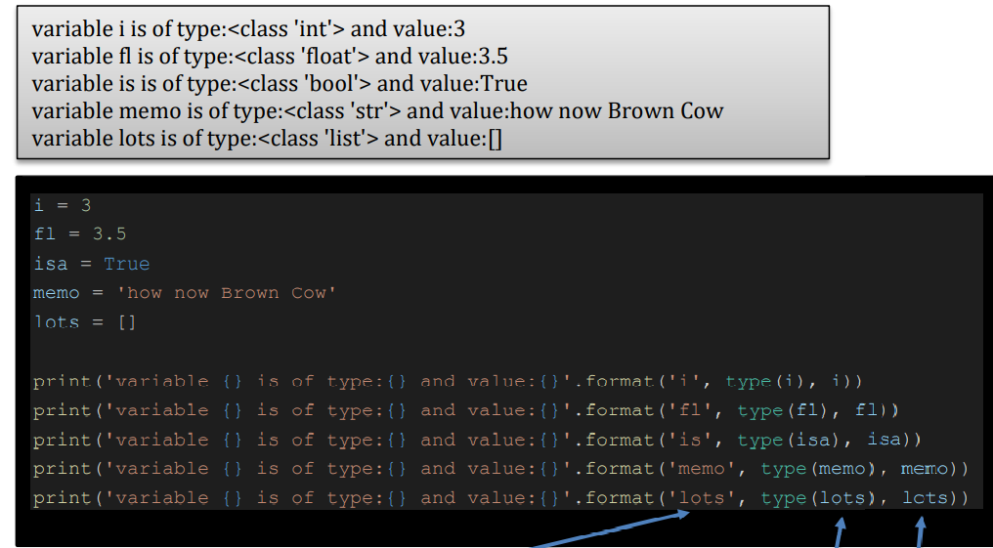

A random answer from a manual list

Len() gives you length